**Siarter Iaith Ysgol Glanrafon**

**Cynllun cenedlaethol i hyrwyddo’r defnydd o Gymraeg**

**Nod**

Nod y Siarter Iaith yw arwain at gynnydd yn nefnydd cymdeithasol plant o’r Gymraeg. Mewn gair, ysbrydoli ein plant a’n pobl ifanc i ddefnyddio’u Cymraeg ym mhob agwedd o’u bywydau. Mae’r Siarter Iaith yn gofyn am gyfranogiad gan bob aelod o gymuned yr ysgol- y cyngor ysgol, y disgyblion, y gweithlu, rhieni, llywodraethwyr a’r gymuned ehangach er mwyn sicrhau perchnogaeth lawn ohoni.

**Siarter Iaith Ysgol Glanrafon**

Mae disgyblion yr ysgol wedi llenwi holiadur i gofnodi’u defnydd cymdeithasol o’r Gymraeg yn yr ysgol, ar yr iard ac o fewn y gymuned. Roedd cyfle hefyd i’r plant nodi pa mor gyffyrddus ydynt wrth weithio, pa mor hyderus ydynt wrth siarad a pha mor bwysig ydi’r Gymraeg iddynt. Rhydd y data yma dystiolaeth bendant o’r sefyllfa ieithyddol gan nodi’r cryfderau ynghyd â’r agweddau ieithyddol fydd angen canolbwyntio arnynt. O ddehongli’r data, bydd cyfle euraidd i blant yr ysgol ac i weddill cymuned ysgol weld pa drywydd fydd angen ei ddilyn a rhoi sylw iddo.

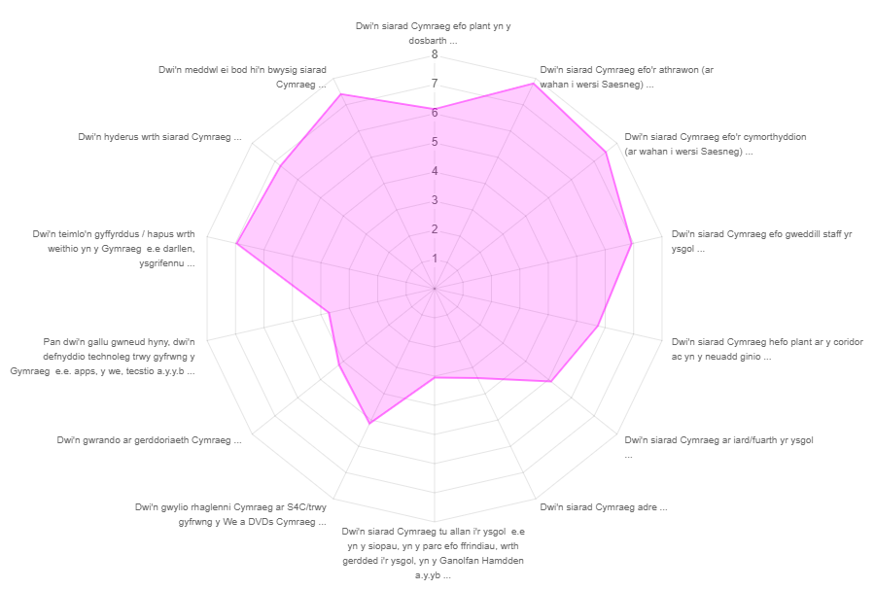

**Fel y gwelwch o’r gwe mesur effaith mae tair agwedd wedi eu hamlygu fel mannau i’w datblygu a rydym fel ysgol wedi bod yn mynd i’r afael â hwy yn ystod y flwyddyn, sef:**

* **Siarad Cymraeg ar fuarth yr ysgol.**
* **defnyddio technoleg trwy gyfrwng y Gymraeg**
* **gwylio rhaglenni Cymraeg**

**Ysgol Glanrafon Language Charter**

**A national initiative to promote the use of Welsh**

**Objective**

The simple objective of the Language Charter is to promote and increase the use of Welsh by children in a social context. In a nutshell, the Charter’s main aim is to encourage and inspire children to speak Welsh. The Language Charter exhorts participation from every member of the school community, and members of the school workforce and council, the pupils and their parents, school governors and the wider community are all encouraged to take full ownership of it.

**Ysgol Glanrafon’s Language Charter**

Ysgol Glanrafon’s pupils have filled a questionnaire to give details about their use of Welsh within the classroom, on the playground and beyond school boundaries within the wider community. It also provided an opportunity to measure how confident children are about conversing or undertaking schoolwork through the medium of Welsh. This data has provided firm evidence to determine which specific aspects we should focus upon. After a period of time, the questionnaire will be revisited - and the same questions asked for a second time – in order to observe what impact has been made in connection with promoting and developing the use of Welsh by our pupils in a number of various contexts.

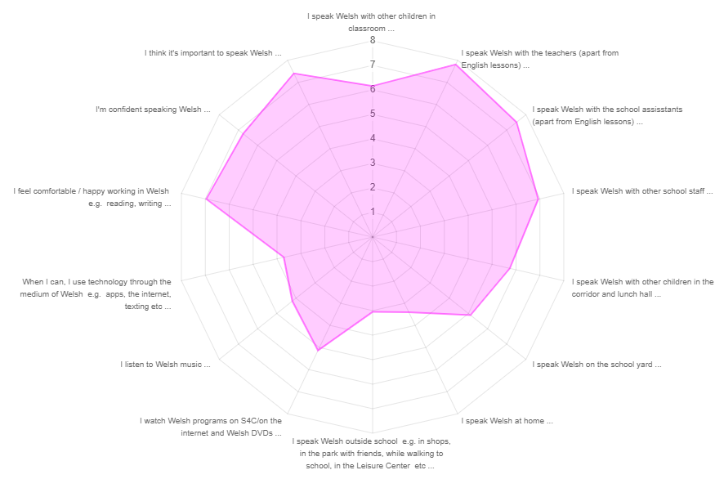

**As you can see from the web there are three areas in particular that evidently need to be addressed over the year :**

* **Speak Welsh on the playground/school yard.**
* **use of technology in Welsh**
* **listen to Welsh music**