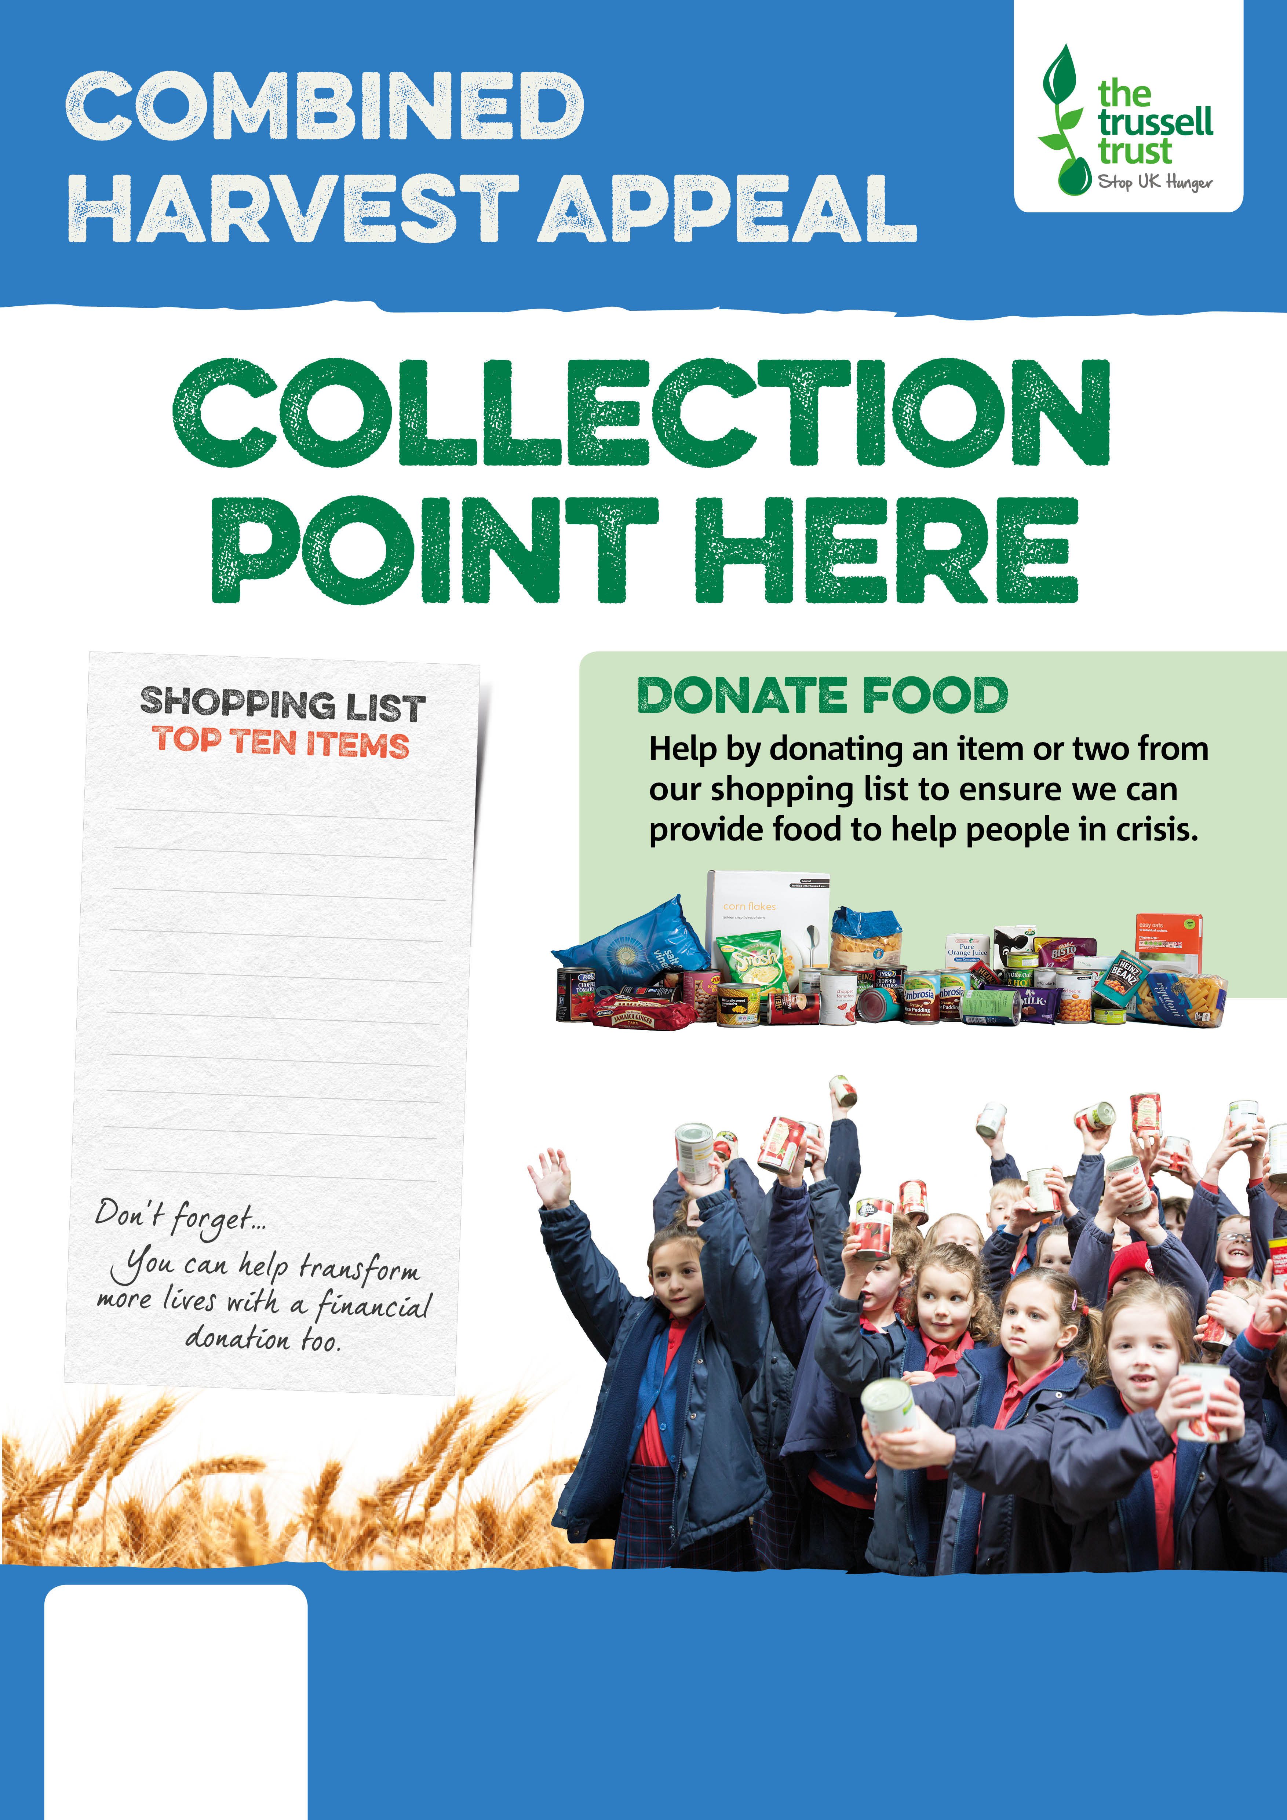

Ready meals

Tinned rice pudding

Toothpaste

Toilet roll

Tinned/packet custard

Tinned meat

Tinned/packet potatoes

Tinned peas or carrots

Tinned tomatoes

Tinned fruit



FLINTSHIRE FOODBANK

flintshire.foodbank.org.uk

Registered Charity in England & Wales (1146921)