

Supporting Children and Young
People During the COVID-19 Pandemic

Guidance for Parents and Carers

Produced by
Flintshire
Educational Psychology Service

31st March 2020

Overview

This is an unsettling and fast changing situation which may be confusing to children.
It is likely that some children may experience greater feelings of anxiety at this time, particularly related to concerns about:
- The virus and risks to the health of themselves and others
- Change and uncertainty
- Loss of social opportunities
- Missed learning and transitions (e.g. exams and moving schools / college)
- Anxiety may look different in each person.

HELPING YOUR CHILD TO MANAGE THEIR WORRIES

- Remember it is okay for children to feel anxious and want lots of reassurance; give them time to talk about their worries
- Try and understand any specific anxieties/worries through listening and talking
- Manage the information that is available to children (e.g. reduce access to news channels and social media)
- Keep a routine and provide structure to the day
- Keep your child busy and active with a wide range of activities (including physical activity)
- Talk about the things we can and cannot control at the moment and make sure they are able to control some elements of their day, e.g. this task or this task
- Help them to stay connected to friends and family (such as video calling and writing letters)
- Consider relaxation activities (helpful links shared in the resources section of this booklet).

TALKING TO YOUR CHILD ABOUT COVID-19
- Be truthful and factual whilst being mindful of your child’s developmental stage
- Allow your child to ask questions
- Give practical advice about how they can help prevent the spread of the virus
- Provide lots of reassurance
- Try as far as possible to manage your own worries
There are links to helpful resources explaining COVID-19 to children and young people at the end of this booklet.

‘HOME-SCHOOLING’ IN THE CURRENT CONTEXT
- Be a parent first and foremost; acknowledge that your relationship is not one of teacher-student
- Primary focus should be on well-being and looking after your family relationships
- Give each other time to get used to the changes
- Avoid putting pressure on yourself to be a teacher or to follow the same curriculum as schools
- Think of yourself as ‘helping’ rather than ‘delivering’ an education
Think about a ‘menu’ of activities that provide a variety of experiences; allow your child some choice
- Have a routine and structure to the day but stay flexible.

Coronavirus and School Closures: Advice for Parents

This advice has been produced by Flintshire Educational Psychology Service in response to the Welsh Government’s announcement that from Friday 20th March, schools will be closed for the majority of children in the UK due to the outbreak of the COVID-19 virus, and are likely to remain closed “for some considerable time”.
It is unknown when schools will be back open, it is a decision which hinges on how well the UK manages to stem the spread of Covid-19.
The UK government has asked schools to continue to provide care for a limited number of children – children who are vulnerable and children whose parents are critical to the Covid-19 response and cannot be safely cared for at home.
The Welsh Government has published a list of five things ‘you need to know’ before sending your children to school or childcare:
- The most recent scientific advice on how to further limit the spread of COVID-19 is clear.
Everyone must, as far as possible, minimise social contact and make sure that anyone who is particularly vulnerable to the virus is able to adopt strict social distancing.
- How does social distancing affect schools and childcare settings?
The Welsh Government have advised schools and childcare should only be open to a limited number of children, to keep the number of children in educational, childcare and play settings to the smallest number possible.
We also need to make sure children are not left with anyone who should be following strict social distancing guidance, such as anyone over 70 or anyone with the specified underlying health conditions.
Keeping children safely in their home should limit the chance of the virus spreading and protect those vulnerable to more serious illness as a result of the virus.
If your child receives free school meals, this will continue. But the way your child gets this food depends on your school. Please check with them.
- What is the latest advice on critical workers?
A list of categories of critical workers has been published on the Welsh Government website.
Places in schools and childcare will be highly limited and only particularly vulnerable children and the children of critical workers whose work is critical to the COVID-19 response should be attending during this time.
If you are classed as a critical worker but are able to perform the critical parts of your job effectively when working from home, then you should do so.
Even for critical workers, provision will only be made in schools or other settings where there is no safe alternative for your family.
- I’m a critical worker but my partner isn’t. What should we do?
If you are in a family where one parent is a critical worker but the other parent is not then the other parent should provide safe alternative arrangements at home when possible.
- I’ve seen different advice from different councils. How are local authorities working?
Local authorities are doing everything they can to deal with the coronavirus pandemic. They made and communicated plans based as part of an initial contingency to deal with the spread of coronavirus.
Those plans will now adapt and change as they respond to the latest guidance available to the Welsh Government. For the very latest advice, please check your local authority’s website and gov.wales/coronavirus.

How might COVID-19 impact my child?

The outbreak and spread of coronavirus presents a challenge for everyone as our normal routines and lifestyles are dramatically changed. Whilst it is often easier to focus on how this affects ourselves as adults, it is important to remember that this will likely affect our children and young people.
Anxiety is a natural response to worrying or upsetting experiences, particularly those that are beyond our control. Our brain releases chemicals to help us deal with difficult situations which can sometimes be useful but sometimes this can lead to negative feelings and behaviour (e.g. anxiety, stress, worry). Children may currently feel anxious.
They might show this in different ways - e.g. they may notice their bodies feel different
(‘Butterflies in their stomach’) or report other feelings (such as sadness, anger). They can also behave differently; might have difficulties with sleeping or a change in appetite; may be more argumentative or irritable; and they may be less able to concentrate and focus on activities. They may also be quieter or may seek comfort or closeness more so than usual and younger children may tantrum more.
Children may also be worried by a particular aspect of the current crisis, for example:

The virus itself
Children of all ages will currently be trying to make sense of the COVID-19 crisis and what it may mean for their family and themselves. They may be concerned for their own health or that of older relatives or family members considered vulnerable.

Change and Uncertainty
Most children do better with routine and for all children their ‘school day’ and life has changed dramatically. On top of this, current information on COVID-19 is changing daily and children may feel confused or uncertain about what is happening. Some children and young people may have lots of questions and adults will not always have answers to these. This will be an unfamiliar experience for most children.

Loss of social opportunities
A key part of attending school and college is socialising with friends, interacting with familiar adults and, for young children, play. Social contact is important for everyone, including children, and contact with peers is particularly important for teenagers. With the closure of nurseries and schools our children and young people are denied this opportunity.
Furthermore, the Government’s policy of social distancing and self-isolation, means that opportunities for socialising outside of these settings is limited.

Missed Learning & Key Transitions
Many children and young people will feel anxious about their missed learning. Many young people face cancelled exams, whilst other children and young people may be worried about falling behind and not making progress in their learning. For those young people in years 6, 11 and 13 - who were facing key tests/exams - they may feel a sense of loss, upset or anger. A lot of pressure is placed on young people to revise and work hard; the opportunity to ‘show’ this hard work has been taken away from them.

The following link provides information on examinations from the Welsh Government:
https://neu.org.uk/advice/coronavirus-advice-and-guidance-exam-cancellation-wales
Many key transition activities will also have been cancelled (trips, proms etc) for these age groups. Endings can be important for all individuals and it is important to be aware that this has been disrupted.

Talking to children about Coronavirus

Top tips for talking to children about COVID-19/Coronavirus:

It is good to talk

- Ensure that the information you share is from a good source such as the NHS and Public Health England; do not rely on information shared via social media.
- Explain the facts of what has and is happening; do not be tempted to give information that is not wholly true.

Be truthful but remember your child’s developmental stage

- Make sure explanations and discussions are age appropriate.
- Younger children may like a cartoon or story.
- Younger children and children with additional needs may also benefit from a social story. There is a link to this in the resources section.
- Older children may appreciate a more factual ‘news’ style (CBBC’s Newsround has lots of helpful videos available online).
- For those who have access to social media, it is important to emphasise the likelihood of misinformation being shared on these platforms and to reiterate reliable sources of information.

Allow children to ask questions

- Allow your child to ask questions. Some children may ask the same questions repeatedly and may need more reassurance.
- Listen as much as you can.

Try to manage your own worries

- Limit access to news on the television and the internet and avoid viewing upsetting information when your children are present (constantly watching updates can increase anxiety).
- Be mindful of when you are watching coverage, e.g. ideally not just before you go to bed.
- Model calmness and share your own coping strategies.

Give practical advice

- Focus on giving them clear practical information and instructions about how to prevent the spread of coronavirus (hand washing, coughing and sneezing into tissues and disposing of these immediately, social distancing etc.).
- Teenagers may benefit from being encouraged to take shared responsibility – to ‘do their bit’ – as they may find social distancing much more difficult.
- Take the opportunity – particularly with older children – to focus on good personal hygiene more generally.
- POINT have provided a useful interactive book http://anyflip.com/psbnb/vgqd/

Provide reassurance

- Remain calm and provide as much reassurance as possible about the virus. For example, ‘most people will recover fully’….’doctors and scientists are working hard to develop treatments and vaccines’ etc.
- Provide reassurance around other worries. For example, ‘there will be opportunities to celebrate endings/transitions’… ‘Everyone is in the same boat with missed learning’…. ‘The government will make sure you get a fair grade’, etc.
- Where children and young people seem worried or anxious try and understand what they might be anxious about – it may be the particular loss of something or fear for a particular person/relative.

The following links will help explain the virus to children:
Mind Heart: I am the Coronavirus

Explaining the Coronavirus: MENCAP Story for Children: ELSA
What is the best approach to home-schooling my child?

Make sure you and your family are healthy – physically and mentally
It is important to ensure that the emotional well-being of yourselves and children is prioritised at this time. In the first days following school closures many children may need more reassurance and everyone will need time to adjust.
Look after your own mental and physical health. You need to be healthy to be able to look after your children. Try and find time in the day and a space to yourself, if that is possible.

Wiltshire Council have produced a useful guide which highlights the importance of the ‘Five Ways to Wellbeing’ (taken from The New Economics Foundation).
The Five ways to wellbeing are a set of evidence-based messages aimed at improving the mental health and wellbeing of the whole population. They were developed by the New Economics Foundation from evidence gathered in the Foresight Mental Capital and Wellbeing project (2008).
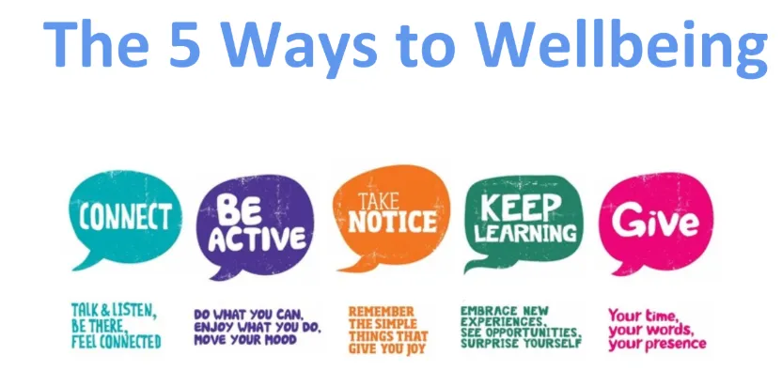
- Connect with the people around you, using technology, letter writing and phone calls.
- Try to ensure you do some physical exercise every day, whilst the current government advice allows.
- Try to be aware of the world around you and notice what you are feeling.
- Try to learn something new.
- Help others in whatever way you can.

Accepting when we cannot control something and focussing on the things we can control can be a powerful way of managing stressful situations. Thecounsellingteacher.com have produced a useful visual reminder of this (https://thecounselingteacher.com).

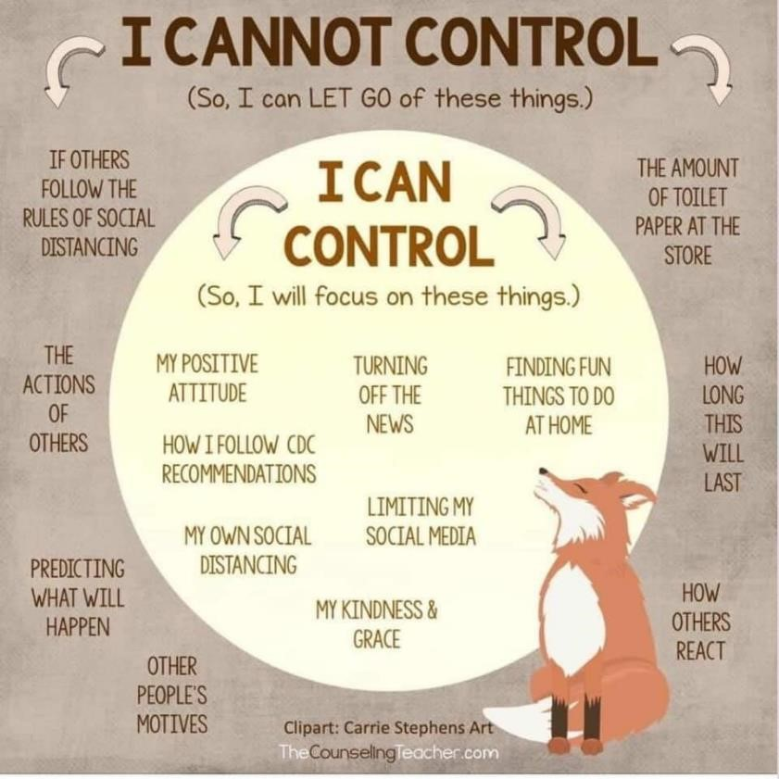

What does my child need?

More important that the ‘curriculum’ or teaching at home is:
- Love and reassurance – this is a confusing and worrying time for many and being a parent first and foremost will be essential.
- Calm parenting – you may not always feel (or be) calm, however, trying to manage your own feelings and taking time to look after yourself will help you in meeting your children’s needs.
- Boundaries – this makes life more predictable for children and young people and will support children in retaining some of the expectations of the school environment. Rewards and incentives may help young children.
- A sense of control – boundaries will need to be balanced with the opportunity for control. This will be particularly important for teenagers.
- Structure and routine – it is important to maintain this for everyone. It can provide predictability and reassurance for children and young people and can also support in balancing the needs of the whole family. This does not have to look the same as others’ routines but having a routine that suits your family and circumstances will be helpful.
- Time to be active – there are many useful websites and free videos to encourage children to be active.
- Space and time to play - Having space from each other where possible. Designated areas can be helpful for some families.
- Social interaction – this will be important for all children and especially teenagers. Utilise modern technology, whilst ensuring e-safety and awareness.
- Balanced screen time – this is usually a challenge and will be even more so during the current climate. Whilst children may spend more time in front of a screen than usual, try to maintain boundaries and limits around this, make it dependent on completing other activities first and ensure they have a healthy ‘diet’ of activities.
- Attuned parenting – this means parenting that notices children’s behaviours and feelings. As noted, children may present differently following such a big change to routine and being aware of this is important.
- Play to your strengths as a parent – if you’re arty embrace that, if you’re a baker utilise this in your activities, etc.
- Start each day like it’s a new day!

Home-schooling – Parent or teacher?

It can feel daunting to home-school your child, particularly where this is unexpected, for an unknown period and under the current circumstances.

It can be hard to know whether to be a parent or a teacher and it is important to remember that they are different roles. As a first step, avoid trying to provide the same education at home as your children gets at school. This will be especially important in the ‘transition’ period, just after school closures when everyone is adjusting.
Also try and not expect the same behaviour and compliance that you know your children might give at school. Children generally respond to their parents differently. You may need to be flexible and give children more choice than they might normally have at school. Many, especially older children, are more likely to ‘buy in’ to new rules and routines if they feel that they have a voice.
Many parents and carers will also be juggling work commitments and caring for others and so being flexible and realistic in your expectations on yourself is important.
Current social distancing policy also means that families are in the same house in a way they are not used to - for an extended period – which can put pressure on relationships. Focus on looking after your relationships with each other – this is more important than the curriculum the children are experiencing. These relationships will be important when they return to school and you are back to just being a parent again
All children will be in the same boat when they return to school and so whilst doing some learning activities will be useful for keeping children busy, do not worry about their progress or how good the learning is.
Having a routine and keeping busy – whatever this looks like - is more important that the details of that routine.
Be reflective rather than critical. This means looking at what has worked/not worked and planning for the next day or week – not being hard on yourself because something hasn’t worked as you hoped. All professionals work in this way and very few teachers get everything right first time, or all of the time.

Planning Your Child’s Day

It is important not to try and replicate a full school timetable but instead have a routine that suits you.
Try to keep bedtime and morning routines close to existing ones to promote a sense of normality to reassure children.
Have a routine in the week which is different to the weekend to help keep them different.
Remember activities like play, exercise and art are fundamental to children’s wellbeing and development and can be used to fill up the day at home. It may be useful to think of your children’s day in terms of a menu of activities – just as you would try to give your children a healthy ‘diet’ regarding food - aim for the same with activities.
Particularly with older children it is useful to think in terms of a list of jobs to complete – they could even choose how and when these will be done.
Where you need to work yourself try and intersperse or ‘block’ activities, so there are periods where children can do some activities independently.
Being flexible and having a routine are not two separate things and a mixture of both will likely best help your child.
Think of home schooling as a river – moving in one direction, but with many twists and turns.


Example Timetable
Here is a suggested way of timetabling your child’s day. Remember this is only a suggestion and is offered to give parents and carers ideas for their own planning. They are provided courtesy of Sandwell Educational Psychology Team.
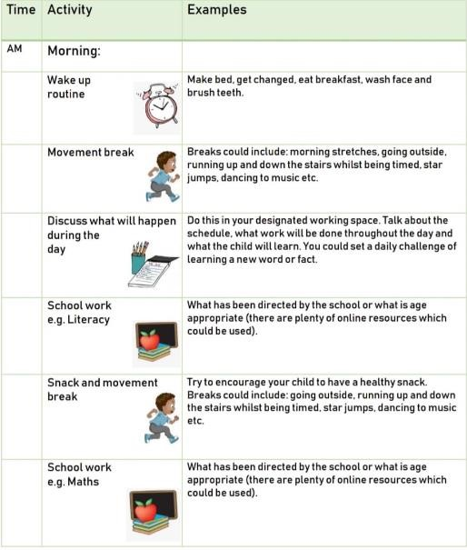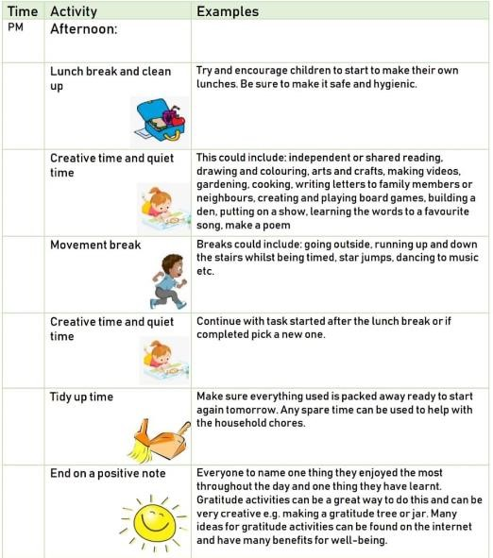

More simplistically you could block the day as ‘adult chosen jobs’ and ‘child chosen jobs’:

Adult chosen job | Child chosen job | break | Adult chosen job | lunch | Child chosen job | Adult chosen job | break | Child chosen job

Or by types of activity/lists of jobs to be done:
Reading  activity | Technology/screen time | Number work | Play | Creative | Physical

And remember, do not worry if that routine does not go to plan!
Returning to School
Currently it is unclear when children and young people will be able to return to school and college. This return may be a challenge for some young people, especially if they have been off for a long time. For children moving from one school/college to another the usual transition process may not have taken place. Once there is further clarity on this situation further guidance will be provided as required.

Special Educational Needs/Vulnerable Children

The Welsh Government’s information about provision for education and childcare can be find via the following link:
https://gov.wales/education-coronavirus
From Monday 23rd March:
- If it is at all possible for children to be at home, then they should be
- If a child needs specialist support, is vulnerable or has a parent who is critical to the Covid-19 response, then provision in an educational or childcare setting should be available for them
- We also need to ensure children are not be left with anyone who should be following stringent social distancing guidance, such as anyone over 70 or anyone with the specified underlying health conditions.
- Schools (and childcare and play settings) should only be open for those children that absolutely need to attend. Residential special schools, boarding schools and special settings should continue to care for children wherever possible.
- Schools should continue to provide care for as small a number of children as possible - children who are vulnerable and children whose parents are critical to the COVID-19 response and cannot be safely cared for at home.
- Vulnerable children including those with safeguarding needs and supported by social care, which include children with care and support or support plans, children on the child protection register and looked after children, young carers, disabled children and those with Statements of special educational needs. The most vulnerable of these should be prioritised.
- Parents should not rely for childcare on anyone who has been advised to follow the stringent social distancing guidance such as grandparents, friends, or family members with underlying conditions
- Parents should do everything they can to ensure children are not mixing socially in ways which could contribute to spreading the virus. Children should observe the same social distancing guidance as adults
- Residential special schools, boarding schools and special settings should continue to care for children wherever possible.
Further and Higher Education
There is information about further and higher education during the coronavirus pandemic addressing the following questions:
Is my college still open?
Will A level, GCSE and vocational examinations/assessments still take place this year?
If I am a learner who is self-isolating or has been diagnosed with COVID-19, can I continue to receive my Education Maintenance Allowance?
Will my college keep their nursery open?
Should colleges take any steps to continue the supply of period products for learners during any closures or other disruptions to learning?
My University is moving to online learning for my course (or providing work for me to complete at home). Will I still receive my student support from Student Finance Wales?
If my University were to close, would I still receive my student support from Student Finance Wales?
If I am ill, will I still receive my student support from Student Finance Wales?
If I have to self-isolate, will I still receive my student support from Student Finance Wales?
I am experiencing financial problems, what help is available to me?
I’m not able to get through to Student Finance Wales to discuss my funding?
I have moved out of halls of residence/private rented student accommodation. Will I have to pay rent for the summer term?
I have moved out of halls of residence/private rented student accommodation and moved back to my parents’ home. Will I retain the same level of maintenance support?
My A levels have been cancelled. How does that affect my application to study at university?
Some higher education providers are changing their offers. What should I do?

SOME HELPFUL RESOURCES & LINKS

ABOUT CORONAVIRUS

A cartoon video explaining more about the Coronavirus appropriate for primary school aged children:
https://www.brainpop.com/health/diseasesinjuriesandconditions/coronavirus/

A short story about the Coronavirus for children who like pictures; also useful for children and young people with social communication needs (e.g. Autism):
https://carolgraysocialstories.com/wp-content/uploads/2020/03/Pandemics-and-theCoronavirus.pdf

Another social story that is specifically relevant to children now learning at home: https://theautismeducator.ie/wp-content/uploads/2020/03/The-Corona-Virus-FreePrintable-Updated-2-The-Autism-Educator-.pdf

A cartoon superhero story to explain the Coronavirus and what you could do to fight it: https://www.elsa-support.co.uk/wp-content/uploads/2020/03/Story-about-Coronavirus.pdf

A comic explaining what the Coronavirus is and what might change or be different for you:
https://www.ppmd.org/wp-content/uploads/2020/03/The-Corona-Virus-Free-PrintableUpdated-2-The-Autism-Educator-.pdf

The BBC Newsround website has lots of helpful and factual videos about Coronavirus:
https://www.bbc.co.uk/newsround

The MindHeart Covibook supports conversations about the virus with younger children:
https://www.mindheart.co/descargables

Explaining the Coronavirus to Children

Mind Heart: I am the Coronavirus
Explaining the Coronavirus: MENCAP
Story for Children: ELSA

Recommended Reads for Parents/ Carers Home Schooling

C J Simister, The Bright Stuff: Playful Ways to Nurture Your Child's Extraordinary Mind

Help for Children and Young People

Childline

Support Line: A Comprehensive list of Support Services for Young People

Links: Websites for Young People Offering Information and Advice

MIND: Contacts for Young People

NHS Helplines

Children and Young People with ASC Resources

Washing your Hands: Sensory Integration and Processing Needs

Social Story by Carol Grey

National Autistic Society Helpline

Support and Resources for Parents/ Carers

Young Minds: Parents Helpline

Council for Disabled Children

Drug Use: Talk to Frank

Adams Psychology: Coping, Resilience and Wellbeing

3ppsychologies.com

Talking to Children and Young People about the Coronavirus

The British Psychological Society: Talking to your Children about Coronavirus
Young Minds: Talking about the Coronavirus
NSPCC: Anxiety and Talking about the Coronavirus
World Health Organisation: Information for Parents and Carers to Share

Information for Adults from the Children’s Commissioner

Media for Children and Young People about the Coronavirus

Cartoon about the Coronavirus

https://www.bbc.co.uk/newsround/51861089

https://www.bbc.co.uk/newsround/51204456

How Germs Spread and why you Should Wash Your Hands

Mindfulness / Relaxation

Explanation of Anxiety, ‘The Guard Dog and the Owl’: Cosmic Kids Zen Den (Primary)

Mindful Schools: Free Mindfulness Classes for Young People and Children

Free Mindfulness Resources from Calm.com

Puppy Mind: A Story to Help Young Children Manage their Thoughts

Be the Pond: A Short Meditation for Young Children to Help Manage Emotions by Cosmic Kids

Movement Meditation for Children who Need to Move: Smiling Minds

Meditations from Calm.com

Sitting still like a frog

The .B and .Paws resources

Bereavement and Grief

Winston’s Wish

Child Bereavement Network https://www.cruse.org.uk/get-help/coronavirus-dealing-bereavement-and-grief

Online Education

Khan Academy
https://www.khanacademy.org
Especially good for maths and computing for all ages but other subjects at Secondary level. Note this uses the U.S. grade system but it's mostly common material.

BBC Learning – All Key Stages
http://www.bbc.co.uk/learning/coursesearch/
From language learning to BBC Bitesize for revision. No TV licence required except for content on BBC iPlayer.

Futurelearn
https://www.futurelearn.com
Free to access 100s of short courses. Mainly for older children and young people of college age. Only pay to upgrade if you need a certificate in your name (own account from age 14+ but younger learners can use a parent account).

Seneca
https://www.senecalearning.com
For those revising at GCSE or A level. Pages of free revision content. Paid access to higher level material.

Openlearn
https://www.open.edu/openlearn/
Free taster courses aimed at those considering Open University but everyone can access it. Adult level, but some e.g. nature and environment courses could well be of interest to young adults.

Blockly
https://blockly.games
Learn computer programming skills - fun and free.

Scratch
https://scratch.mit.edu/explore/projects/games/
Creative computer programming

Ted Ed
https://ed.ted.com
All sorts of engaging educational videos

National Geographic Kids https://www.natgeokids.com/uk/
Activities and quizzes for primary age children

Duolingo
https://www.duolingo.com
Learn languages for free. Web or app.

Mystery Science
https://mysteryscience.com
Free science lessons

The Kids Should See This https://thekidshouldseethis.com
Wide range of cool educational videos

Crash Course https://thecrashcourse.com
You Tube videos on many subjects

Crash Course Kids
https://m.youtube.com/user/crashcoursekids
As above for a younger audience

Crest Awards
https://www.crestawards.org
Science awards you can complete from home.

iDEA Awards https://idea.org.uk
Digital enterprise award scheme you can complete online.

Paw Print Badges
https://www.pawprintbadges.co.uk
Free challenge packs and other downloads. Many activities can be completed indoors. Badges cost but are optional.

Tinkercad
https://www.tinkercad.com
All kinds of making.

Prodigy Maths https://www.prodigygame.com
Is in U.S. grades, but good for UK Primary age.

Cbeebies Radio
https://www.bbc.co.uk/cbeebies/radio
Listening activities for the younger ones.

Nature Detectives
https://naturedetectives.woodlandtrust.org.uk/naturedetectives/
A lot of these can be done in a garden, or in the forests, if you live in one.

British Council
https://www.britishcouncil.org/school-resources/find
Resources for English language learning

Oxford Owl for Home https://www.oxfordowl.co.uk/for-home/
Lots of free resources for Primary age

Big History Project
https://www.bighistoryproject.com/home
Aimed at Secondary age. Multi-disciplinary activities.

Geography Games
https://world-geography-games.com/world.html Geography gaming!

Blue Peter Badges
https://www.bbc.co.uk/cbbc/joinin/about-blue-peter-badges If you have a stamp and a nearby post box.

The Artful Parent
https://www.facebook.com/artfulparent/
Good, free art activities

Red Ted Art
https://www.redtedart.com
Easy arts and crafts for little ones

The Imagination Tree https://theimaginationtree.com
Creative art and craft activities for the very youngest.

Toy Theater https://toytheater.com/ Educational online games DK Find Out
https://www.dkfindout.com/uk/?fbclid=IwAR2wJdpSJSeITf4do6aPhff8A3tAktnmpaxqZbkgudD49l71ep8-sjXmrac Activities and quizzes

Twinkl
https://www.twinkl.co.uk

SOME USEFUL TOOLS

- A parent reflection sheet to help you think about the week.
You can also use this to record any concerns if you feel you need to talk through these with a professional.

- A child evaluation sheet which can be used to monitor your child’s well-being and also to encourage them to have a voice during this period.
The first version is better suited to younger children and the second version to older children.

- A blank timetable

- A Family Agreement

- A Menu of Shared Activities

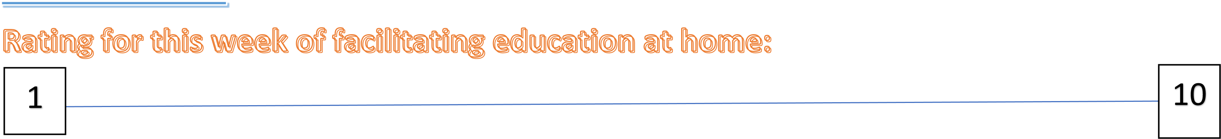

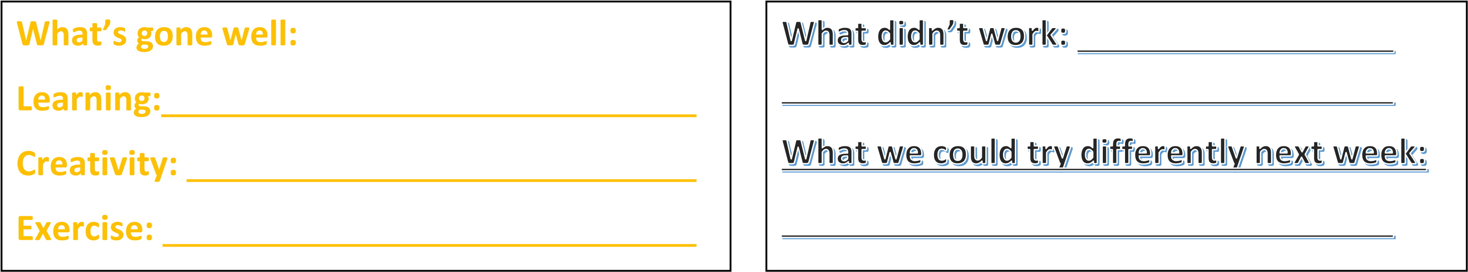

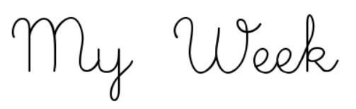

  I didn’t like…
  _____________________________
  _____________________________
  _____________________________
  _____________________________ _____________________________
  _________________
  _____________________________
  I liked…
  _______________________________
  _______________________________
  _______________________________
  _______________________________
  _______________________________
  _______
  _______________________________

XXXDAY: XXX’s ACTIVITY MENU
TIME | ACTIVITY
BREAKFAST AND DRESS | BREAKFAST AND DRESS
9.00 – 9.40

9.40 – 10.00

10.00 – 11.00

11.00 – 11.40

11.40 – 12.15

LUNCH | BREAKFAST AND DRESS
1.15 – 2.00

2.00 – 2.30

2.30 – 3.00

3.00 – 3.30

Family Agreement

This is an example of a family agreement that you may want to
decide to use as a family. It is useful because it brings everyone together so that
everyone can contribute, and everyone can share their thoughts and feelings.
Having choice is important and children and young people will value the opportunity
to voice their choices, to be included and to be able to express their views.
This agreement has purpose and meaning and should make everyone feel valued
because they are contributing to how the family can help and support each other in
this new reality, rather than being told what to do by the adults. It may also be helpful
in the days and weeks ahead to remind each other of what was agreed in your
family, particularly if the children and young people say, ‘it’s not fair’.
Once you have decided together what is important to all of you to support each
other, your agreement could be drawn as poster, created on a computer, collaged, or
made in any way that you choose. Try and have two copies and put them in the
areas of your home that you share together, for example, on the fridge to remind you
of what your family values.
If the agreement needs changing after a while, sit back down together as a family
and talk it through. Discuss as a family why the original agreement isn’t working for
everyone, and problem solve this. It may mean that you alter your agreement
slightly, but what is important is that everyone invests in this and you work out what
works for you as a family.

The ______________ family agree that while we are all at home together, we will team up
And help each other by:

Getting up together at (insert time).
Having breakfast together at (insert time).
Deciding together what our activity menus are for the day and getting
Dressed.
Deciding together who will use the laptop and/ or iPad and what times we
Will use them.
Deciding together what our jobs are in the house (like who will wash the
Pots/ load the dishwasher).



