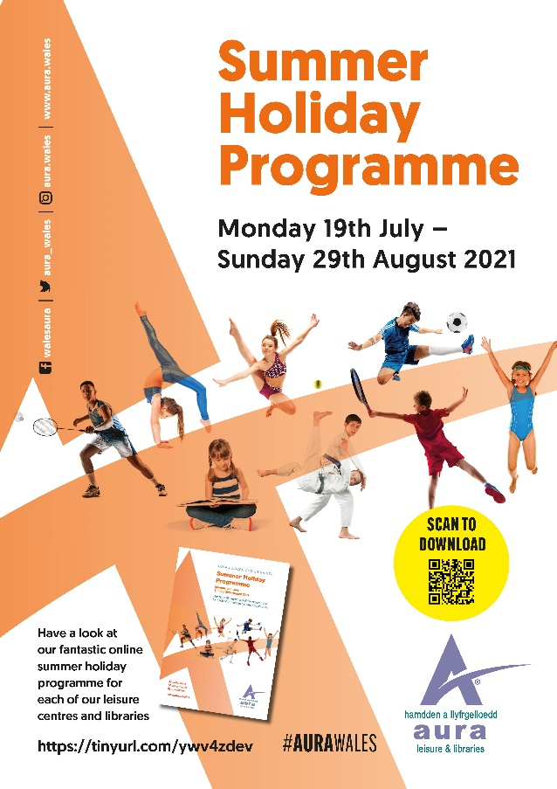

Have a look at our fantastic online summer holiday programme for each of our leisure centres and libraries.
https://tinyurl.com/ywv4zdev
Edrychwch ar ein rhaglen gwyliau haf ar-lein ar gyfer pob un o’n canolfannau hamdden a llyfrgelloedd.
https://tinyurl.com/ysdspbxd

