Gorffennaf 15 fed 2022

Bwletin Ysgol Glanrafon



Gobeithio y cewch chi haf gwerth chweil. Diolch i bawb am eu cefnogaeth y flwyddyn yma o dan amgylchiadau heriol dros ben!

*We do hope you have a lovely summer. Thank you all for your support during this challenging year!*



Diolch o galon i’r holl staff am eu gwaith caled y tymor yma. Diolch hefyd i’n disgyblion bendigedig ni. Rydym yn dymuno pob lwc i ddisgyblion blwyddyn 6 sydd yn symud i Ysgol Maes Garmon ym mis Medi.

*Many thanks to all the staff for their hard work this term. Thanks also to our amazing pupils. We wish our year 6 pupils all the very best as they move to Ysgol Maes Garmon in September.*

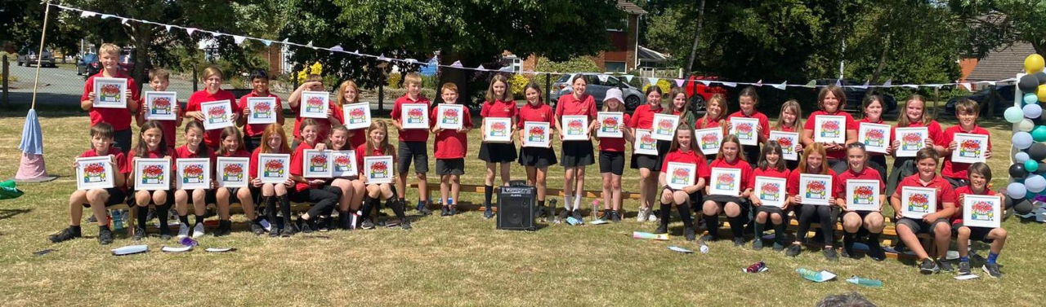

Ymddeoliad /Retirement

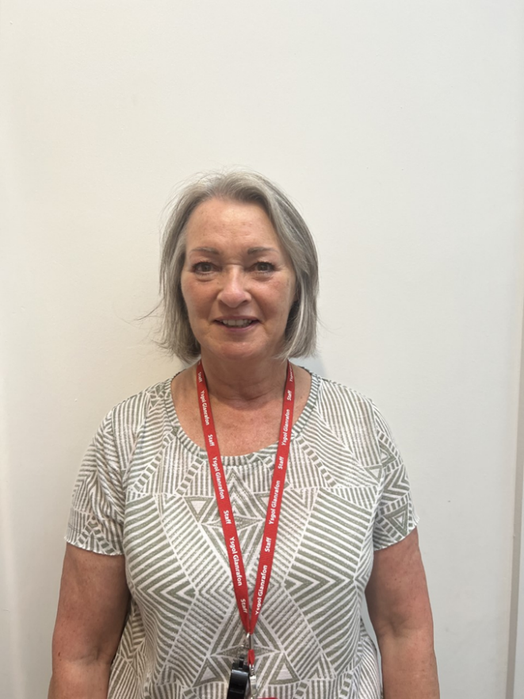

Mae Ms Giddins wedi bod yn gymorthydd arbennig yn yr ysgol ers deng mlynedd. Mae hi’n ran allweddol o’n tim ac wedi bod yn gyfrifol am gymorth cyntaf ers blynyddoedd lawer. Mae hi’n helpu yn y dosbarth ac allan amser cinio ar y buarth. Rydym yn dymuno’n dda iddi ar ei hymddeoliad ac fe fydd na golled ar ei hôl.

*Ms Giddins has been an amazing classroom assistant at the school for ten years. She is a key part of our team and has been responsible for first aid for many years. She helps out in the classroom and out at lunchtime on the playground. We wish her well in her retirement and she will be sadly missed*.

Symud ymlaen/Moving on

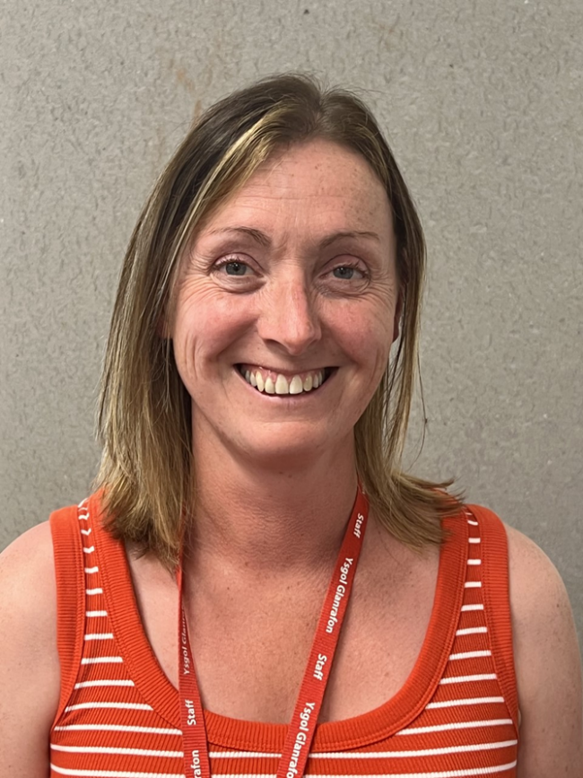

Mae Mrs Coulman wedi bod yn athrawes yn yr adnawdd anghenion ychwanegol ers wyth mlynedd a hanner mlynedd. Mae hi wedi helpu llawer o ddisgyblion ac wedi bod yn cefnogi sawl teulu. Mae disgyblion wrth eu boddau gyda Mrs Coulman. Rydym yn dymuno’n dda iddi yn ei swydd newydd yn Ysgol Mochdre. Fe fydd colled ar ei hôl.

**Mrs. Sioned Coulman**

Sioned has been a teacher in the additional needs resourced provision for 8 and a half years. She has helped many pupils and has been supporting many families. The pupils bond very well with Mrs Coulman. We wish her well in her new job at Ysgol Mochdre. She will be sadly missed.

Symud ymlaen/Moving on

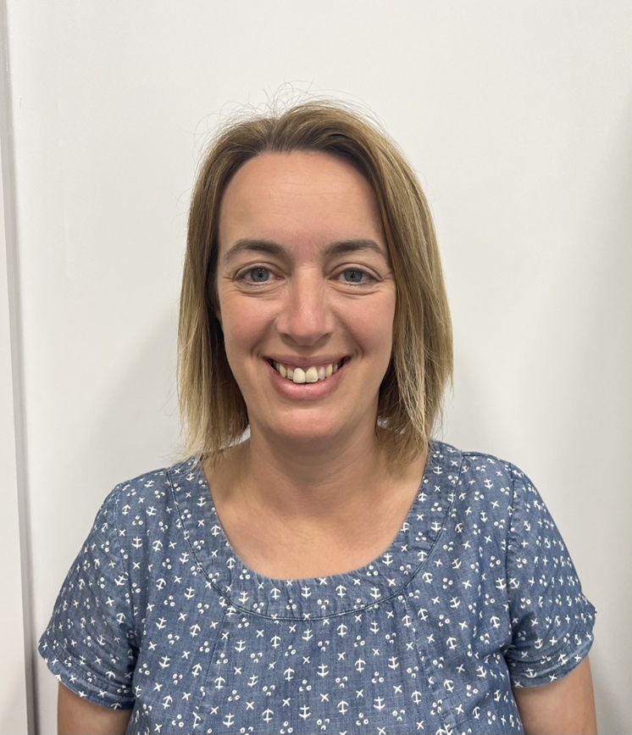

**Mrs Lowri Hogg**

Mae Mrs Hogg wedi bod yn aelod gweithgar iawn o’r staff ers 9 mlynedd. Mae ei chyfraniad i Ysgol Glanrafon yn un gwerthfawr dros ben. Dros y blynyddoed, mae wedi rhoi oriau maith o’u hamser ei hun, er mwyn rhoi cyfle i ddisgyblion gystadlu yn yr Urdd. Mae hi’n athrawes dawnus ac fe fydd colled ar ei hôl. Rydym yn dymuno’r gorau iddi yn ei rôl newydd fel dirprwy yn Ysgol Plas Coch.

**Mrs*. Lowri Hogg***

*Mrs Hogg has been a very active member of staff for 9 years. Her contribution to Ysgol Glanrafon is enormous and has been invaluable. She has given hours of her time to teach pupils for the Urdd and has had great success. She is a talented teacher and who will be sadly missed. We wish her well in her new role of deputy at Ysgol Plas Coch.*

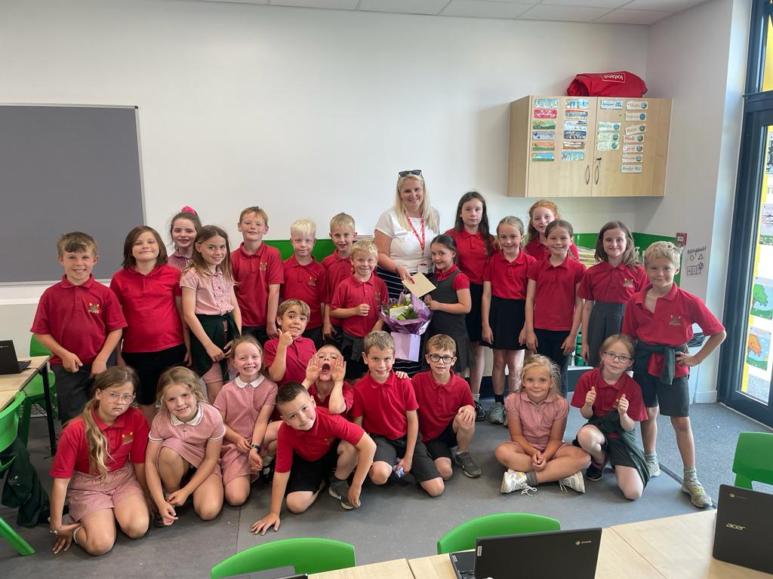

Mae Miss Lia Edwards wedi bod yn gymorthydd rhan amser dros y flwyddyn. Rydym yn diolch iddi am ei hyblygrwydd a’i chymorth dros y flwyddyn.

Miss Lia Edwards has been a part time teaching assistant at Ysgol Glanrafon during the past year. We thank her for her flexibility and her help during the year.

Medi/September 2022

|  |  |  |
| --- | --- | --- |
|  |  |  |
| 1/9/22 | Hyfforddiant mewn swydd | Teacher training |
| 2/9/22 | Hyfforddiant mewn swydd | Teacher training |
| 5/9/22 | Ysgol yn agor | School opens |
|  |  |  |

Asesiadau Personol adborth dysgwyr haf 2022

Personal Assessments summer learner feedback 2022

Clwb

Ar agor i arbed lle o 1/9/22

Open to book your place from 1/9/22

Blwyddyn 2

Mae canlyniad asesiadau personol Cymraeg a Mathemateg (rhesymeg ac gweithdrefnol) ar gael trwy gyfrif hwb eich plentyn.

Blwyddyn 3, 4, 5 a 6

Canlyniadau asesiadau personol Cymraeg, Saesneg a Mathemateg (gweithdrefnol a rhesymeg) ar gael trwy gyfrif hwb eich plentyn

*Year 2*

*Your child’s Welsh and Mathematics (procedural and reasoning) results are available from their Hwb account*

*Years 3, 4, 5 and 6*

*The result of your child’s personal assessments for Welsh, English and Mathematics (reasoning and procedural) are available through your child’s Hwb account*







.



Tudalen 2







