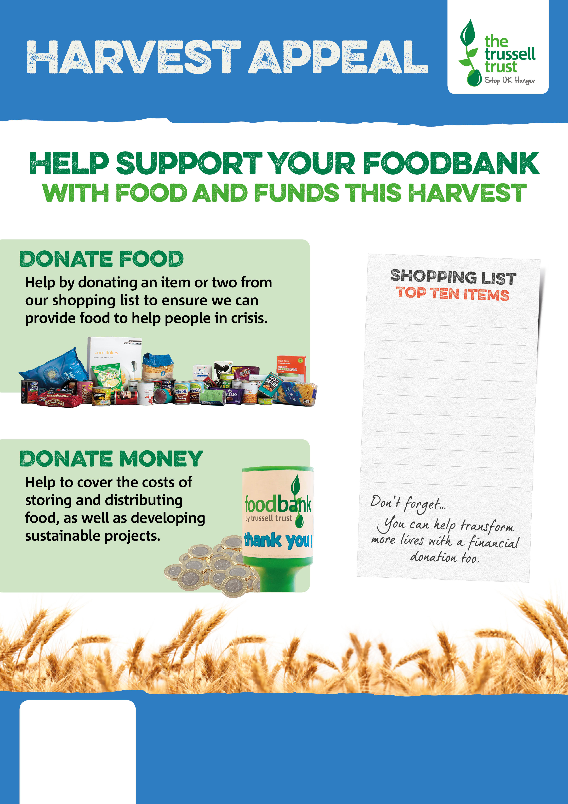

FLINTSHIRE FOODBANK
www.flintshire.foodbank.org.uk
Registered Charity in England & Wales (1146921)

Tinned potatoes
Pot noodle/instant pasta
Packet rice (ready made)
Ready meals
Shampoo
Tinned fish
Tinned sweetcorn
Pasta sauce
Tinned/packet custard
Squash

